***WEBSITE***

* **INTRODUCTION:**

We have designed a website using HTML about the previous topic 2D game. 2D game has been created using the concept of object oriented language (OOP) and also by using SFML which is an external language of C++. We have designed an adventure game where the hero kills the enemy and reach to different levels and gain points. We have created the characters by using Photoshop (pixel version) and have done the animation.

* **PURPOSE:**

The purpose of designing this website was to know about the development of a website and about the language used in it HTML. This was proved beneficial for those who had an interest in web development we got to learn about the GUI and other computer arts related things.

* **LANGUAGE USED:**

The language used was HTML.

* **FRONT PAGE:**

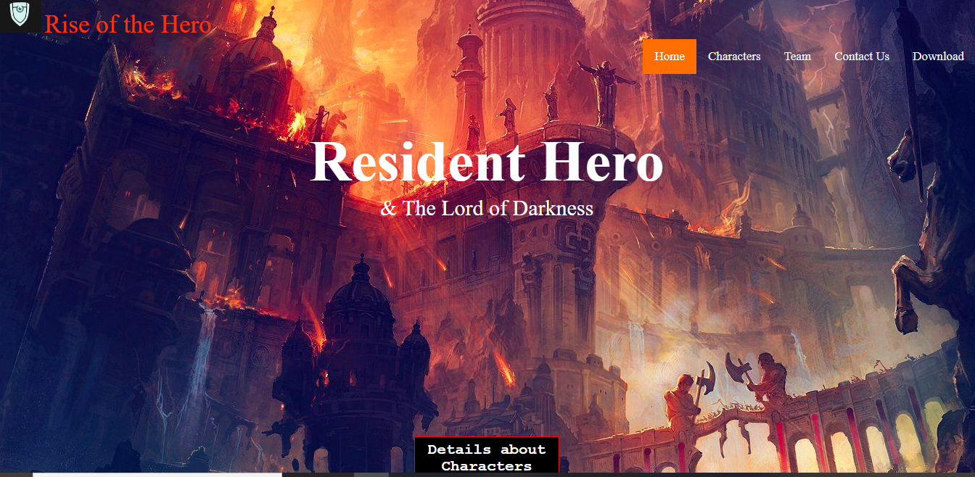

* **OTHER OUTLOOK OF WEBSITE:**
* Characters:

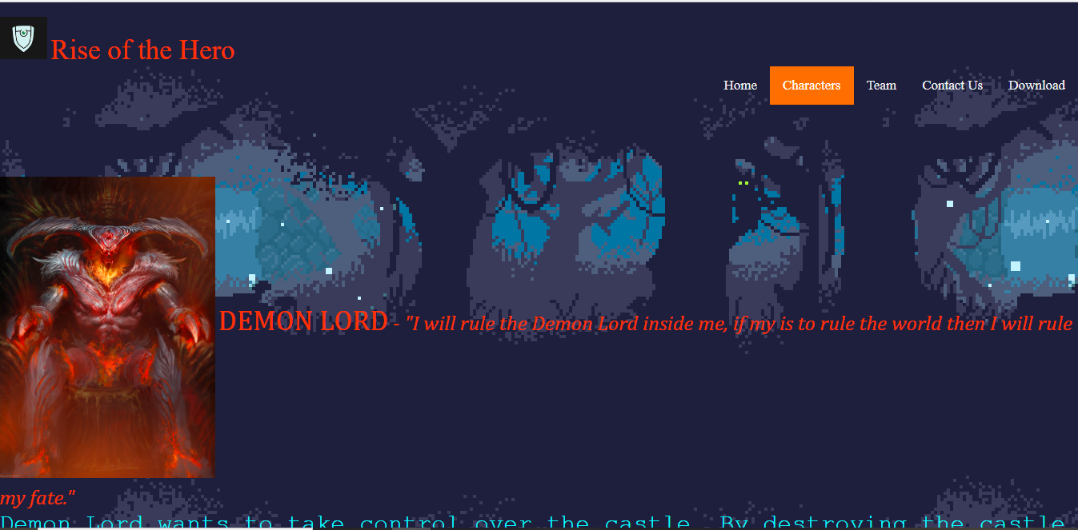

* Contact us:

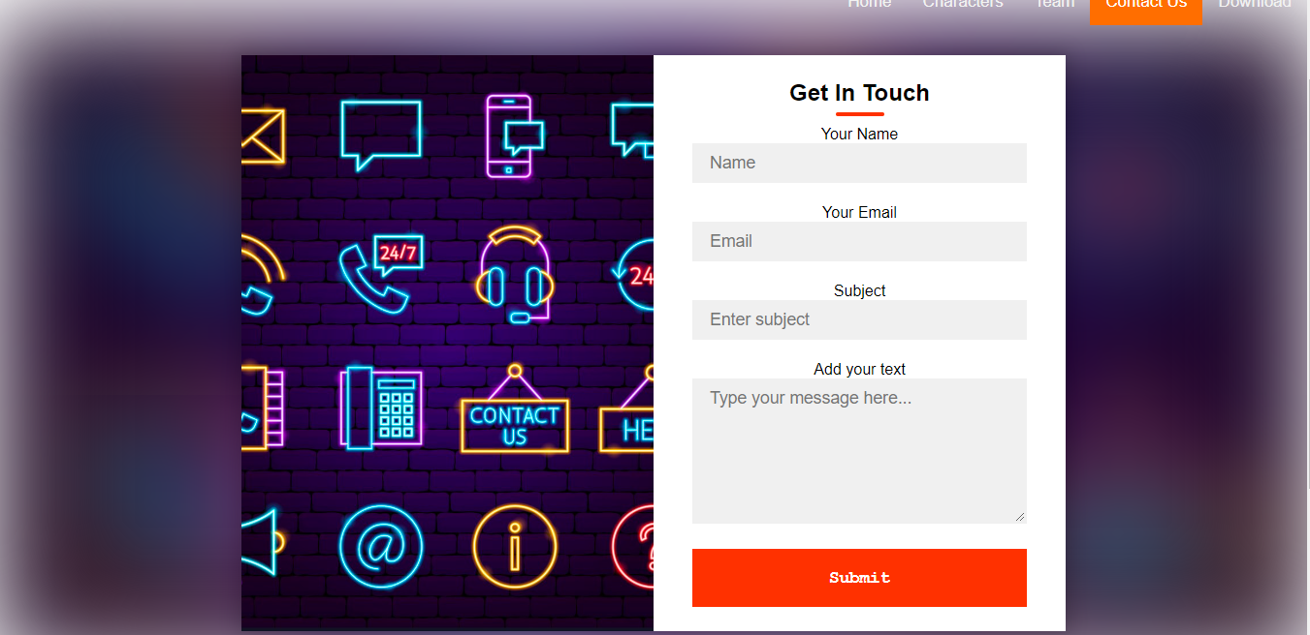

* Download:
* 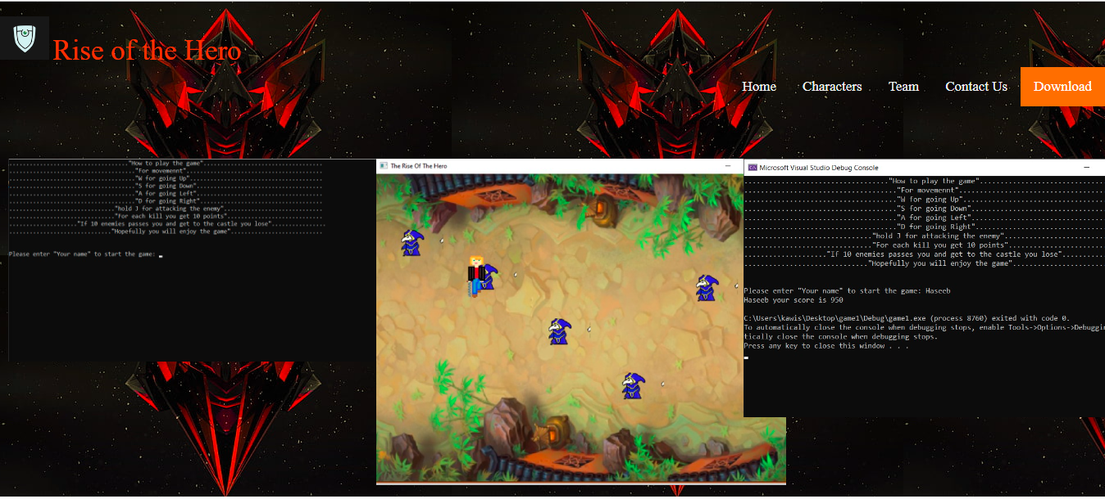Site Map:

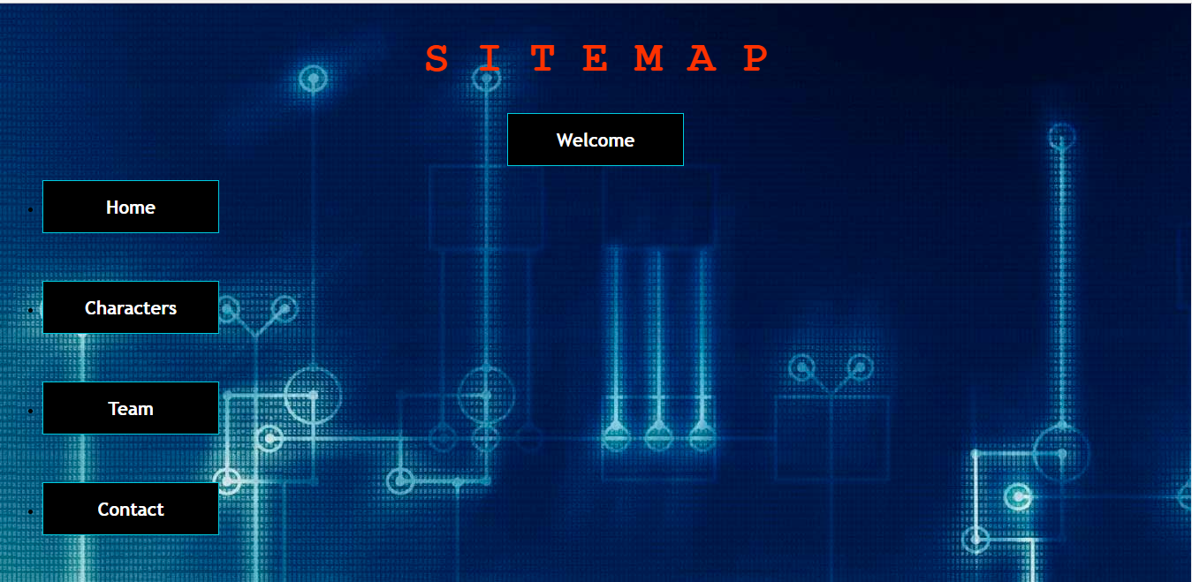

* **CONCLUSION:**

In conclusion we got a little idea about how the website is created and also about the HYPER TEXT MARKUP LANGUAGE (HTML). Which was an interested experience for the future web developers.

………………………………………………………………………………………………………………………………